

Requirement & Design Specification
Restaurant Ordering Management System (ROMS)
Version: 1.0

– Da Nang, September 2026 –

Record of Changes
Version | Date | A*  M, D | In charge | Change Description
v1.0 |  | A | Dương Trong | Initialized RDS document from template; completed Cover page, Record of Changes, Contents. Wrote I.1.1 Actors (Customer, Waiter, Kitchen Staff, Cashier, Manager, System) and I.1.2 Use Case List
v1.1 |  | A | Phạm Minh Đức | Added Part II – Requirement Specifications: FR-01 → FR-16, grouped by feature (Common / Customer / Kitchen & Staff / Manager)
v1.2 |  | A | Ngô Viết Bảo Huy | Added I.2.1 Screens Flow and I.2.2 Screen Descriptions for the Customer flow: QR → Table → Dining Session → Menu → Cart → Order
v1.3 |  | A, M | Dương Trong | Added IV.3 Business Rules BR-01 → BR-14 and Order State Machine; updated Use Case Spec "Place Order", "Cancel Order" to align with BR-04, BR-05, BR-06
v1.4 |  | A | Ngô Viết Bảo Huy | Added I.2.3 Screen Authorization (screen × role matrix) and I.2.4 Non-UI Functions (QR token verification, real-time event broker, payment IPN, no-show auto-release)
v2.0 |  | A | Phạm Minh Đức | Added I.3.1 Database Design (ERD + data dictionary) and I.3.2 Code Packages following Spring Boot layered architecture
v2.1 |  | A ,M | Phạm Minh Đức | Added III.1.2 System Access: API list, JWT + RBAC design, Q R token HMAC-SHA256 mechanism; updated Assumptions & Dependencies
v2.2 |  | M | Dương Trong | Finalized real-time technology (WebSocket/STOMP over SockJS) for FR-07, FR-09, FR-10; updated Non-UI Functions and Limitations
v2.3 |  | M | Ngô Viết Bảo Huy | Updated Customer Screen Descriptions based on M3 demo results (end-to-end ordering)
v2.4 |  | A, M | Phạm Minh Đức | Added Kitchen Display System and Real-time Table Map design; updated Order status transition sequence after M4 demo
v2.5 |  | A, M | Dương Trong | Added Reservation, Bill Aggregation, Payment Settlement (Cash/VNPay) and Manager Dashboard; updated BR-13 for Reservation vs Walk-in conflict handling
v2.6 |  | A | Dương Trong | Added FR-17 System Settings Management and BR-15 (configurable Reservation lock time / no-show release time); updated FR-14 to reference configurable values instead of hardcoded ones
v2.7 |  | M, D | Ngô Viết Bảo Huy | Updated document based on Sprint 7 Test Report (duplicate order/Idempotency Key, optimistic locking, payment timeout); removed FUTURE-scope items from the Requirement section
v3.0 |  | M | Dương Trong | Reviewed entire document, aligned Part IV – Appendix, updated Contents and page numbers; released final version for defense
*A - Added M - Modified D - Deleted

Contents
Record of Changes 2
I. Overview 4
1. User Requirements 4
1.1 Actors 4
1.2 Use Cases 5
2. Overall Functionalities 10
2.1 Screens Flow 10
2.2 Screen Descriptions 10
2.3 Screen Authorization 13
2.4 Non-UI Functions 15
3. System High Level Design 16
3.1 Database Design 16
3.2 Code Packages 19
II. Requirement Specifications 23
1. Common Functions 23
2. Customer Ordering & In-Dining Feature 25
3. Floor Service & Kitchen KDS Feature 33
4. Cashier Billing & Administration Feature 36
III. Design Specifications 38
1. Authentication & System Access 38
2. Table QR & Dining Session Management 41
3. Digital Menu Operations & Batch Ordering 44
4. Kitchen Order Processing (KDS) 47
IV. Appendix 54
1. Assumptions & Dependencies 54
1.1 Assumptions 54
1.2 Dependencies 56
2. Limitations & Exclusions 56
2.1 Excluded Features 56
2.2 Technical & Operational Limitations 57
3. Business Rules 57
4. .. 59

I. Overview

1. User Requirements

1.1 Actors

# | Actor | Description
1 | Customer  (Diner / Guest) | The end-user dining at the restaurant. They interact with the system via a mobile web browser by scanning the table's QR code. A customer joins or initiates an active Dining Session, browses the digital menu, manages the shopping cart, places food orders, tracks real-time order status (PENDING → SERVED), and submits service requests (calling staff, requesting bills).
2 | Waiter  (Service Staff) | Front-of-house staff responsible for physical customer service. They monitor the table status map, assist guests with ordering or order adjustments if needed, receive notifications when dishes are marked as READY by the kitchen, deliver food to tables, and update order item status to SERVED. They also receive and attend to customer assistance calls.
3 | Kitchen Staff  (Cook / Chef) | Back-of-house staff operating the Kitchen Display System (KDS). They receive incoming orders, acknowledge and accept orders, update preparation states (CONFIRMED → PREPARING → READY), or reject items (REJECTED) in case ingredients are out of stock.
4 | Cashier | Front-of-house staff handling billing and settlement. They access active dining sessions, consolidate all placed orders into a single final bill, apply discounts (if applicable), process payments (cash or QR/bank transfer), confirm payment status, complete the Dining Session, and release the table to AVAILABLE.
5 | Restaurant Manager  (Admin) | High-level administrator supervising restaurant operations. They manage staff accounts and role authorizations, configure restaurant tables and generate secured table QR codes, manage menu categories and food items (prices, images, availability), and review dashboard analytics (daily revenue, order volumes, popular items).
6 | Payment Gateway  External System | An external software system (e.g., VNPay, Momo, or VietQR/Banking API) that interfaces with the system to process non-cash transactions, validating payment statuses and returning transaction callbacks/webhooks to the backend.

1.2 Use Cases

a. Diagram(s)

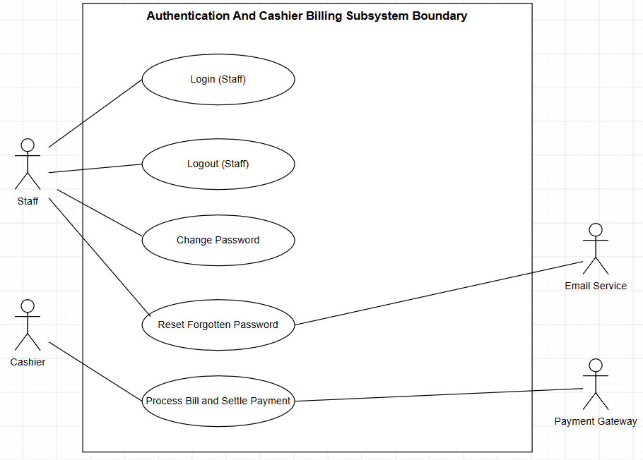

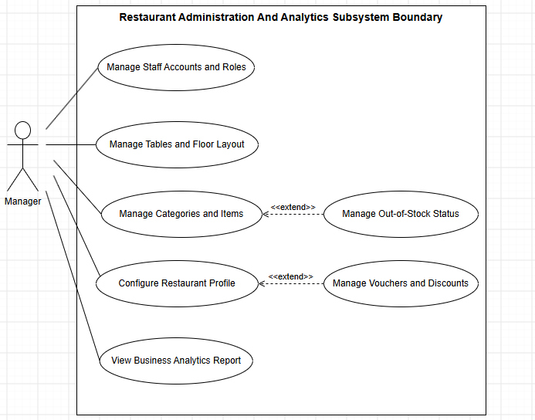

b. Descriptions

ID | Feature | Use Case | Actor(s) | Use Case Description
UC‑01 | Authentication | Login System | All Staff | Allows internal staff (Manager, Cashier, Waiter, Kitchen) to authenticate into the system using credentials to receive role-based JWT tokens.
UC‑02 | Authentication | Logout System | All Staff | Allows authenticated staff to safely terminate their active session and invalidate their security token.
UC‑03 | Authentication | Manage Personal Profile | All Staff | Allows staff members to view and update their personal contact information, phone number, and avatar.
UC‑04 | Authentication | Change Password | All Staff | Enables authenticated staff to update their password by confirming old password and providing a new strong password.
UC‑05 | User Management | Manage Staff Accounts | Manager | Enables manager to create new staff accounts, update info, filter, toggle active/inactive status, and reset credentials.
UC‑06 | User Management | Manage Roles & Permissions | Manager | Allows manager to assign operational roles (Waiter, Kitchen, Cashier, Manager) and configure access privileges.
UC‑07 | Table Management | Manage Restaurant Tables | Manager | Allows configuring dining area: adding tables, modifying seat capacity, assigning dining zones, and setting availability.
UC‑08 | Table & QR | Generate & Export Table QRs | Manager | Generates cryptographically signed QR codes containing secure table tokens and exports printable cards for tables.
UC‑09 | Table & QR | Scan QR & Join Session | Customer | Customer scans table QR; backend verifies token, identifies table, and attaches customer to the active Dining Session.
UC‑10 | Floor Management | Monitor Live Table Map | Staff | Displays visual grid of all tables with color-coded live states (Available, Active Session, Reserved, Needs Cleaning).
UC‑11 | Menu Management | Manage Food Categories | Manager | Allows creating, updating, reordering sequence, and toggling visibility of categories (Appetizers, Mains, Drinks).
UC‑12 | Menu Management | Manage Food Items & Pricing | Manager | Enables adding and updating dishes: setting price, uploading photos, descriptions, and toggling in-stock/sold-out status.
UC‑13 | Menu Operations | Browse & Search Digital Menu | Customer, Waiter | Allows diners and waitstaff to browse categories, search items by name or price range, and view ingredients and photos.
UC‑14 | Menu Operations | View Food Recommendations | Customer | Displays rule-based suggestions (popular pairings, chef specials, budget combos) requiring customer confirmation before adding.
UC‑15 | Cart Operations | Manage Shopping Cart | Customer, Waiter | Allows adding dishes to cart, modifying quantities, adding notes (less ice, no spicy), and removing items.
UC‑16 | Ordering | Place Order | Customer | Submits dishes in cart to the active Dining Session using an idempotency key to prevent duplicates, creating order in PENDING.
UC‑17 | Ordering | Place Order on Behalf | Waiter | Enables waitstaff to create and submit food orders directly into the session for walk-in guests or diners not using phones.
UC‑18 | Ordering | Track Live Order Status | Customer, Waiter | Provides real-time visibility into ordered items: PENDING → CONFIRMED → PREPARING → READY → SERVED.
UC‑19 | Ordering | Cancel / Adjust Pending Order | Customer, Waiter | Allows canceling order items only while PENDING or CONFIRMED; strictly prevents cancellation once PREPARING starts (BR-05).
UC‑20 | Kitchen (KDS) | View Kitchen Order Queue | Kitchen | Displays a prioritized Kanban queue of incoming food orders on KDS, sorted by arrival time, urgency, and category.
UC‑21 | Kitchen (KDS) | Update Preparation Status | Kitchen | Allows chefs to acknowledge orders (CONFIRMED), start cooking (PREPARING), and signal when dishes are cooked (READY).
UC‑22 | Kitchen (KDS) | Reject Order Item with Reason | Kitchen | Allows kitchen staff to reject an item due to ingredient exhaustion, triggering an immediate notification to table and waiter.
UC‑23 | Serving | Serve Dish to Table | Waiter | Waiter receives instant notifications for READY dishes, delivers items to table, and marks status as SERVED.
UC‑24 | Service Call | Request In-Dining Assistance | Customer | Allows diners to send service requests (call waiter, refill ice/water, extra utensils, request bill check) via phone.
UC‑25 | Service Call | Handle Service Requests | Waiter | Enables waitstaff to monitor live requests across assigned tables, claim tasks, and mark them resolved after serving.
UC‑26 | Billing | Process Billing & Settle Payment | Cashier, Gateway | Aggregates all orders in session, generates final bill, processes payment (cash/banking QR), completes session, and frees table.
UC‑27 | Reservation | Manage Reservation & Check-in | Customer, Staff | Enables guests to reserve tables in advance; staff checks in guests upon arrival; auto-cancels no-shows.
UC‑28 | Analytics | View Sales Analytics Dashboard | Manager | Generates analytics charts on revenue, total orders, table turnover rate, peak hours, and best-selling dishes.
UC‑29 | Ordering | Force Cancel / Void Item | Waiter, Manager | Allows waitstaff or managers to force-cancel or void an item from the session bill during incidents (unexpected stockout, customer complaint, delayed preparation) with a mandatory audit reason.
UC‑30 | Table Management | Transfer Dining Session | Waiter, Cashier | Allows staff to transfer all active session data (guest list, cart, pending/served orders, accumulated bill) from current table to a new available table when guests request to switch seats.
UC‑31 | Menu Operations | Route Drink Orders (Bypass Kitchen) | System | System automatically classifies orders: beverage/ice items immediately bypass the kitchen queue (KDS), transition directly to READY status, and alert waitstaff to fetch from bar/fridge.

2. Overall Functionalities

2.1 Screens Flow
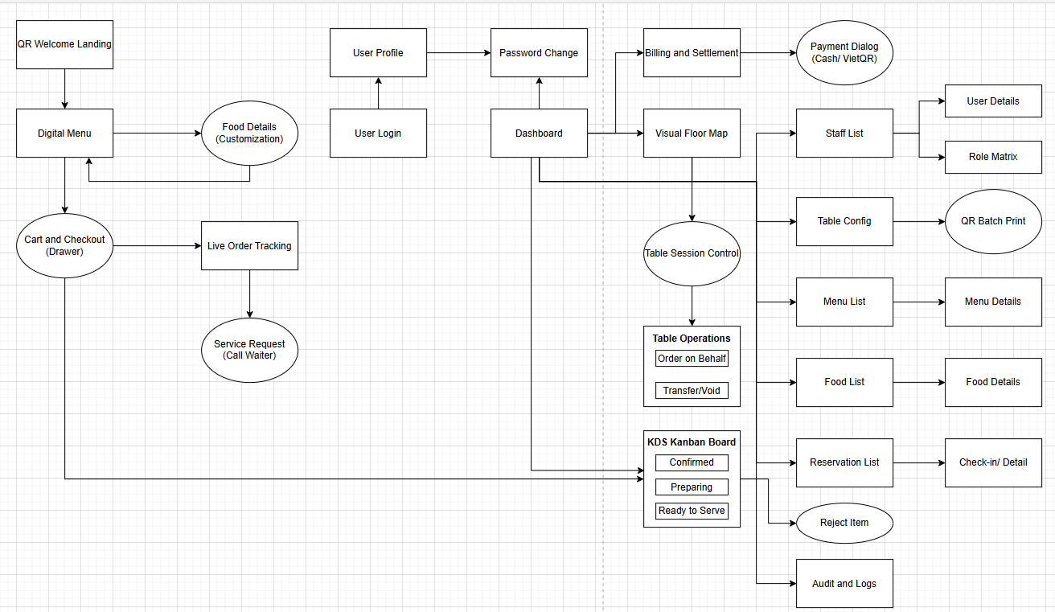

2.2 Screen Descriptions

# | Feature | Screen | Description
1 | Authentication | SCR‑01: Login Screen | Internal staff authentication screen for Managers, Cashiers, Waiters, and Kitchen staff. Accepts username/password credentials, verifies password hash via BCrypt, generates a JWT token embedding user role and dining context, and redirects the user to their designated role-specific homepage.
2 | User Management | SCR‑02: Staff Account List | Employee account administration screen for Managers: paginated data table of all staff members with full-text search by name/username, filtering by role (Manager, Cashier, Waiter, Kitchen) and status (Active/Locked), with quick actions to toggle account status.
3 | User Management | SCR‑03: User Profile Form | Modal dialog for creating new staff accounts or updating existing employee profiles: inputs for full name, phone number, email address, role selection dropdown, status toggle, and an administrative button to reset the user's password to default.
4 | User Management | SCR‑04: Role & Permission Matrix | Subsystem authorization matrix screen: provides visual audit of assigned permissions (View, Edit, Admin) across all roles against system features, allowing Managers to verify role boundaries and security governance policies.
5 | Table Management | SCR‑05: Dining Table Config | Dining table master configuration screen: data grid listing table numbers, seating capacity (2, 4, 6, 8 pax), dining area zones (Floor 1, Floor 2, Outdoor Patio), operational status (Available / Maintenance), and options to register or modify physical dining tables.
6 | Table Management | SCR‑06: QR Code Batch Print | Batch QR code generation and print preview screen: displays preview cards containing HMAC-SHA256 encrypted tamper-proof table QR codes with restaurant branding; provides high-resolution PNG image downloads and multi-table print-ready PDF exports.
7 | Floor Management | SCR‑07: Visual Floor Map | Interactive graphical floor layout partitioned by floor zones for Waiters and Cashiers: color-coded table nodes reflecting real-time dining state (Green = Available, Red = Occupied, Yellow = Reserved, Grey = Cleaning), displaying elapsed dining time and guest headcount.
8 | Floor Management | SCR‑08: Table Session Control | Operational control modal triggered when staff clicks an occupied table: displays active session details, cumulative ordered items, action buttons to "Assist Order" (SCR-10), "Transfer Table" (UC-30), and privileged "Void Item" (UC-29).
9 | Customer Entry | SCR‑09: QR Welcome Landing | Mobile web landing screen displayed when guests scan tabletop QR codes: decrypts and validates HMAC token, identifies table number, binds guest browser to the active table session, and presents a prominent "Start Ordering" call to action.
10 | Menu & Ordering | SCR‑10: Digital Menu & Ordering | Primary digital food catalog interface on mobile browsers: top keyword search bar, horizontal category filter tabs, food cards with appetizing pictures, descriptions, pricing, out-of-stock badges, quick "+" add buttons, and a sticky checkout bar.
11 | Menu & Ordering | SCR‑11: Food Details (Popup) | Food customization modal: displays high-resolution photo, allergen warning, portion selection, modifier options (sugar level, ice level, spice level), customer custom preparation notes input, and dynamic subtotal recalculation before adding to cart.
12 | Cart & Ordering | SCR‑12: Cart & Checkout Drawer | Sliding cart drawer overlay: lists selected dishes with itemized notes, quantity steppers (+/-), single or batch removal controls, itemized subtotal, tax preview, and a prominent "Place Order" button that submits orders to the dining session.
13 | Order Tracking | SCR‑13: Live Order Status | Real-time progress tracking screen for table guests: lists all ordered dishes alongside dynamic lifecycle status indicators (CONFIRMED → PREPARING → READY → SERVED) synchronized via WebSocket, with self-cancellation button for unstarted items.
14 | Service Request | SCR‑14: In‑dining Service Request | Quick-assistance tabletop modal for seated diners: one-touch buttons for water refill, extra ice, tableware/napkins, direct staff assistance, and checkout request. Dispatches real-time audible/visual alerts to floor waiters.
15 | Kitchen Operations | SCR‑15: KDS Kanban Board | Kitchen Display System (KDS) board organized into 3 kanban swimlanes: Queued (CONFIRMED), In Preparation (PREPARING), and Ready to Serve (READY). Displays table numbers, order timestamps, preparation elapsed timers, and action buttons ("Cook", "Done", "Reject").
16 | Kitchen Operations | SCR‑16: Reject Item Modal | Kitchen rejection dialog triggered when ingredients are depleted or equipment malfunctions: chef selects or types a rejection reason; updates item status to REJECTED and dispatches instant push alerts to both the diner and floor staff (UC-22).
17 | Billing & Settlement | SCR‑17: Billing & Settlement | Cashier checkout management screen: table selector, itemized aggregation of all SERVED items across session orders, coupon/voucher code discount inputs, automatic 8% VAT computation, total balance due display, and payment progression button.
18 | Billing & Settlement | SCR‑18: Payment Processing Dialog | Payment fulfillment dialog: dual tabs for Cash (cash tendered input, automatic change calculation) and VietQR transfer (renders dynamic QR containing exact total payable and order reference), thermal K80 receipt printing, and session closure.
19 | Analytics | SCR‑19: Sales Analytics Dashboard | Executive management dashboard: summary KPI cards for daily/monthly gross revenue, customer guest volume, peak hour traffic distribution bar charts, table turnover metrics, and ranking table of the top 5 bestselling food items.
20 | Reservation | SCR‑20: Reservation Management | Table reservation management screen: chronological booking roster, guest name, contact phone, party size, assigned table numbers, reservation confirmation actions, and a "Check-in" button that converts reservations into active dining sessions.
21 | Audit & Logs | SCR‑21: Audit & Cancellation Logs | Managerial compliance and loss-prevention audit screen: searchable historical logs of all cancellation events (pre-cook customer cancellations, kitchen rejections, and manager forced void items) with immutable timestamps, staff IDs, and mandatory reasons.

2.3 Screen Authorization
- V (View): View-only permissions.
- E (Edit / Execute): Data manipulation, status updates, and interactive operations.
- A (Admin): Full administrative control (CRUD, configuration, and audit logs).
- ‑ (None): Access denied (enforced at both UI routing and API backend levels).

Screen ID | Screen Name | Customer | Waiter | Kitchen | Cashier | Manager
SCR‑01 | Login Screen | ‑ | V / E | V / E | V / E | V / E
SCR‑02 | Staff Account List | ‑ | ‑ | ‑ | ‑ | A
SCR‑03 | User Profile Form (Modal) | ‑ | V / E* | V / E* | V / E* | A
SCR‑04 | Role & Permission Matrix | ‑ | ‑ | ‑ | ‑ | A
SCR‑05 | Dining Table Config | ‑ | ‑ | ‑ | ‑ | A
SCR‑06 | QR Code Batch Print | ‑ | ‑ | ‑ | ‑ | A
SCR‑07 | Visual Floor Map | ‑ | V | ‑ | V | V
SCR‑08 | Table Session Control (Modal) | ‑ | V / E | ‑ | V / E | A
SCR‑09 | QR Welcome Landing | V | ‑ | ‑ | ‑ | ‑
SCR‑10 | Digital Menu & Ordering | V | V | ‑ | ‑ | V
SCR‑11 | Food Details & Customization | V / E | V / E | ‑ | ‑ | A
SCR‑12 | Cart & Checkout Drawer | V / E | V / E | ‑ | ‑ | ‑
SCR‑13 | Live Order Status | V | V | ‑ | ‑ | ‑
SCR‑14 | In‑dining Service Request | V / E | V | ‑ | ‑ | ‑
SCR‑15 | KDS Kanban Board | ‑ | ‑ | V / E | ‑ | V
SCR‑16 | Reject Item Modal | ‑ | ‑ | E | ‑ | A
SCR‑17 | Billing & Settlement | ‑ | ‑ | ‑ | V / E | V
SCR‑18 | Payment Processing Dialog | ‑ | ‑ | ‑ | E | A
SCR‑19 | Sales Analytics Dashboard | ‑ | ‑ | ‑ | ‑ | V
SCR‑20 | Reservation Management | ‑ | V / E | ‑ | ‑ | A
SCR‑21 | Audit & Cancellation Logs | ‑ | ‑ | ‑ | ‑ | V

2.4 Non-UI Functions

# | Feature | System Function | Description
1 | Security & QR | FN‑01: QR Token Generator & Verifier | Backend cryptographic utility that generates HMAC-SHA256 encrypted tamper-proof tokens embedding table identifiers and a server-side secret key during QR stand printing, and validates signature integrity upon customer scan (BR-04), completely preventing table identity spoofing.
2 | Order Lifecycle | FN‑02: Order State Transition Validator | Central state machine validator engine: strictly enforces legitimate order item lifecycle transitions (PENDING → CONFIRMED → PREPARING → READY → SERVED), rejecting illegal state jumps and preventing customer self-cancellation once food preparation has commenced (BR-05, BR-06).
3 | Order Routing | FN‑03: Beverage / Drink Bypass Router | Automated order routing rule engine: upon order placement, items flagged as pre-packaged beverages or bar items (is_drink = 1) bypass the kitchen cooking queue, are automatically set to READY, and dispatch a serving task directly to floor waiters (UC-31).
4 | Concurrency | FN‑04: Idempotency Key & Dedup Service | Server-side request deduplication service: validates unique Idempotency-Key headers (UUID v4) attached to each place-order request within an active Dining Session, preventing accidental duplicate orders caused by double-clicking or intermittent mobile network retransmissions (BR-03).
5 | Reservation | FN‑05: Scheduled Reservation Auto-Release | Background cron job executing every 5 minutes: scans upcoming table reservations; if current time exceeds reservation scheduled arrival by more than 20 minutes without customer check-in, automatically transitions the booking to EXPIRED and resets table status to AVAILABLE (BR-07).
6 | Payment Gateway | FN‑06: Payment Webhook & IPN Listener | Asynchronous payment gateway notification webhook endpoint (VietQR / VNPay Sandbox): verifies digital transaction signatures, matches reference order codes and amounts, updates bill records to PAID, and signals automatic session completion.
7 | Analytics | FN‑07: Daily Sales Metric Aggregator | Scheduled nightly aggregation worker executing at 00:05 daily: aggregates total net sales, dish volume counts, table turnover ratios, and void/cancellation losses; updates historical reporting data models to support rapid analytics dashboard queries (UC-28).

3. System High Level Design

3.1 Database Design

a. Database Schema
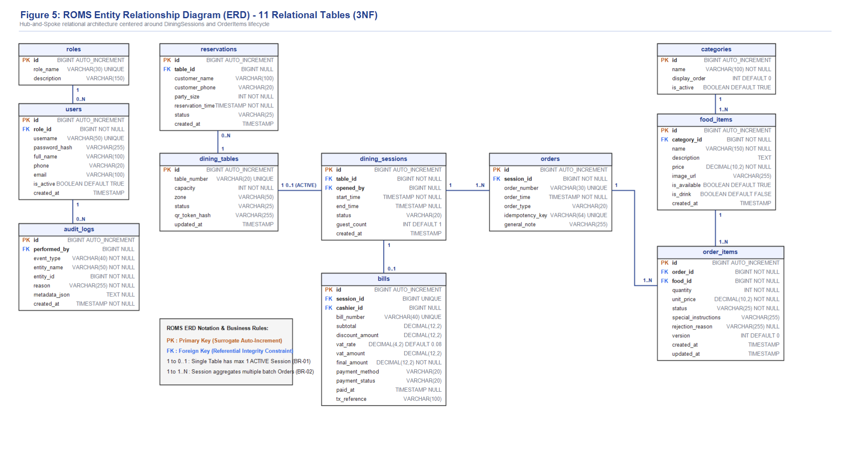

b. Table Descriptions

No | Table | Description
01 | roles | Stores system roles for Role-Based Access Control (RBAC): Manager, Cashier, Waiter, and Kitchen.  - Primary keys: id  - Foreign keys: None
02 | users | Stores internal staff accounts, BCrypt-hashed credentials, contact details, assigned role, and active/locked status flag.  - Primary keys: id  - Foreign keys: role_id (references roles.id)
03 | dining_tables | Stores physical restaurant table layouts, table numbers, seating capacities (2/4/6/8 pax), dining area zones (Floor 1, Floor 2, Outdoor), physical status (AVAILABLE, OCCUPIED, RESERVED, CLEANING), and HMAC-SHA256 encrypted QR secret signature.  - Primary keys: id  - Foreign keys: None
04 | dining_sessions | Core Hub Entity: Represents an active dining occupancy for a specific table. Created upon customer QR scan or staff assignment (ACTIVE), tracks start/end timestamps and party size, and is finalized upon payment settlement (CLOSED).  - Primary keys: id  - Foreign keys: table_id (references dining_tables.id), opened_by (references users.id, nullable)
05 | categories | Stores food and beverage classification groupings (Starters, Main Courses, Hotpot/Grill, Desserts, Beverages) with display sequence and activation flags.  - Primary keys: id  - Foreign keys: None
06 | food_items | Stores menu items including names, descriptions, base prices, image URLs, availability flags, and an is_drink indicator for automatic kitchen queue bypass.  - Primary keys: id  - Foreign keys: category_id (references categories.id)
07 | orders | Represents an individual batch order submission within an active dining session. Multiple orders can belong to a single dining session. Tracks order timestamp, order type (CUSTOMER or WAITER_ASSISTED), and UUID idempotency key.  - Primary keys: id  - Foreign keys: session_id (references dining_sessions.id)
08 | order_items | KDS State Machine Entity: Tracks individual ordered food items, quantity, snapshot unit price, customer special preparation notes, rejection reason, optimistic locking version, and lifecycle status (CONFIRMED → PREPARING → READY → SERVED, or REJECTED / CANCELLED).  - Primary keys: id  - Foreign keys: order_id (references orders.id), food_id (references food_items.id)
09 | bills | Stores financial checkout transactions for a completed dining session: aggregates subtotal of all SERVED items, voucher discount amount, 8% VAT tax amount, final payable amount, payment method (CASH / VIETQR), payment status, and bank transaction reference.  - Primary keys: id  - Foreign keys: session_id (references dining_sessions.id, UNIQUE), cashier_id (references users.id)
10 | reservations | Stores customer advance bookings: guest contact details, party size, scheduled arrival time, pre-assigned table, and status (PENDING, CONFIRMED, CHECKED_IN, EXPIRED, CANCELLED).  - Primary keys: id  - Foreign keys: table_id (references dining_tables.id, nullable)
11 | audit_logs | Immutable audit log capturing sensitive operations: kitchen item rejections (REJECT_ITEM), waiter/manager item voids (VOID_ITEM), table transfers, and cancellations with mandatory reason notes and actor identification for loss prevention.  - Primary keys: id  - Foreign keys: performed_by (references users.id, nullable)

3.2 Code Packages
[Provide the package diagram for each sub-system. The content of this section including the overall package diagram, the explanation, package and class naming conventions in each package. Please see the sample & description table format below]
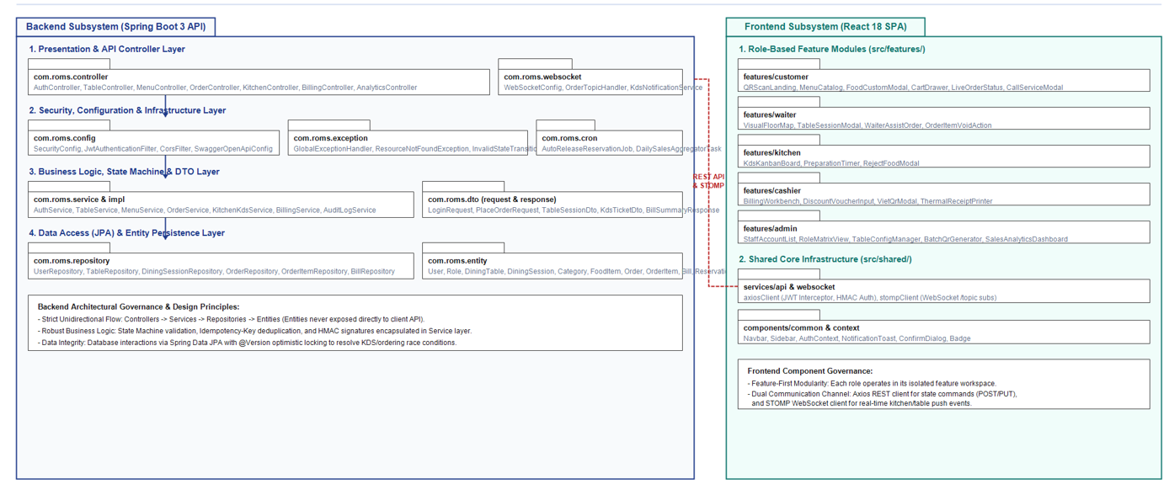
Package descriptions

No | Package | Description
01 | com.roms.config | Contains enterprise infrastructure configuration beans: Spring SecurityFilterChain, JwtAuthenticationFilter, CORS policy filter, OpenAPI/Swagger 3 documentation, and PasswordEncoder (BCrypt).
02 | com.roms.controller | REST API presentation controllers handling incoming HTTP requests, validating input DTOs, enforcing role-based endpoint security, and dispatching tasks to services (AuthController, TableController, MenuController, OrderController, KitchenController, BillingController, AnalyticsController).
03 | com.roms.dto | Data Transfer Objects separated into request and response subpackages: encapsulates client-server payload schemas, preventing direct external exposure of internal database JPA entities.
04 | com.roms.service & impl | Encapsulates core domain business logic, transactional boundaries (@Transactional), State Machine progression rules, HMAC-SHA256 signature verification, Idempotency deduplication, and VietQR dynamic payload computation.
05 | com.roms.repository | Spring Data JPA data access interfaces providing optimized CRUD and JPQL query methods with native query support for sales aggregation and optimistic lock execution.
06 | com.roms.entity | Persistent JPA Entity domain classes mapping directly to the 11 relational database tables with validation annotations, relational foreign key mappings, and @Version concurrency control fields.
07 | com.roms.websocket | STOMP over WebSocket broker configuration and messaging handlers: broadcasts real-time push events to client channels (/topic/table/{id} for diner status updates, /topic/kitchen for KDS tickets, /topic/waiter for assistance rings).
08 | com.roms.cron | Scheduled background cron worker tasks: AutoReleaseReservationJob executing every 5 minutes to release expired bookings, and DailySalesAggregatorTask executing at 00:05 daily to calculate revenue metrics.
09 | com.roms.exception | Centralized error handling infrastructure: GlobalExceptionHandler using @RestControllerAdvice, custom domain exceptions, and standardized RFC-7807 ErrorResponse formatting.
10 | src/features/customer | React frontend customer ordering workspace: mobile-optimized UI modules for QR welcome landing, digital menu browsing, dish customization modal, cart drawer, live order tracking, and service request modal.
11 | src/features/waiter | React frontend floor staff workspace: real-time visual floor map, table session operational controls, staff-assisted tabletop ordering, and manager-authorized item voiding.
12 | src/features/kitchen | React frontend Kitchen Display System (KDS): high-contrast touch-friendly 3-column Kanban board, preparation countdown timers, and food item rejection modal.
13 | src/features/cashier | React frontend cashier checkout workbench: consolidated table billing review, discount coupon entry, dynamic VietQR modal generation, and thermal K80 receipt printing triggers.
14 | src/features/admin | React frontend management dashboard: staff account CRUD, role authorization matrix, table physical layout editor, batch QR code PDF generator, and executive sales analytics charts.
15 | src/shared | Cross-cutting frontend core utilities: Axios HTTP client with JWT interceptors, STOMP client wrapper, AuthContext provider, and reusable UI components (Navbar, Sidebar, Modals, Toast alerts).

II. Requirement Specifications

1. Common Functions

1.1 UC-01_Login System (Staff RBAC Authentication)
a. Functional Description
UC ID and Name | UC-01_Login System
Created By | ROMS Development Team
Date Created | 16/09/2026
Primary Actor | Restaurant Staff (Waiter, Kitchen Staff, Cashier, Manager)
Secondary Actors | System Security Service (JWT Provider, Rate Limiter)
Description | Authenticates internal staff credentials, verifies RBAC roles, and issues signed JWT tokens for role-based dashboard access.
Trigger | Staff member opens the internal portal and submits login credentials.
Preconditions | Staff account exists in SQL Server with status ACTIVE. Network is reachable.
Postconditions | JWT token stored securely; user redirected to assigned operational view (Table Map, KDS, POS, or Dashboard).
Normal Flow | 1. User accesses staff login view (/staff/login).  2. System presents login form requesting Username/Email and Password.  3. User inputs valid credentials and taps "Sign In".  4. Backend validates input syntax and verifies BCrypt hash against database.  5. System checks account status is ACTIVE.  6. System generates signed JWT containing user_id and role claim.  7. System logs successful login into AuditLog.  8. System redirects user to their assigned portal based on role.
Alternative Flows | 4a. Temporary Password:  1. If account has flag must_change_password = true, System redirects to Password Change screen (UC-03).
Exceptions | 4b. Invalid Credentials:  1. If credentials mismatch, System increments failed attempt counter.  2. If failed attempts >= 5, account is locked for 15 minutes.  3. System returns error: "Invalid username or password."  5a. Account Suspended:  1. If account is inactive, System displays: "Account deactivated. Contact manager."
Priority | High / Must Have
Frequency of Use | Continuous (Multiple times per shift across all staff)
Assumptions | HTTPS TLS 1.3 enforced for all credential transmissions.
b. Business Rules
- BR-07 (Role-Based Access Control): Only authenticated staff with verified roles can access operational portals (Waiters handle floor tables; Chefs handle KDS cooking; Cashiers handle bill settlements; Managers possess full administrative oversight).
- Staff Account Active Status: Authentication succeeds only if the employee account is active (status = 'ACTIVE'). Locked accounts are denied access.

2. Customer Ordering & In-Dining Feature

2.1 UC-09_Scan Table QR Code & Initialize Session
a. Functional Description
UC ID and Name | UC-09_Scan Table QR Code
Created By | ROMS Development Team
Date Created | 16/09/2026
Primary Actor | Customer (Diner at table)
Secondary Actors | System (QR Validation Engine, Session Manager)
Description | Customer scans physical QR code on dining table. System decodes cryptographic token, binds to active Dining Session (or creates new one), and opens digital ordering menu.
Trigger | Customer scans QR code sticker on dining table using phone camera.
Preconditions | Physical table has active QR sticker. Customer has smartphone with web browser and internet.
Postconditions | Session token saved in browser storage. Customer connected to active DiningSession; digital menu displayed.
Normal Flow | 1. Customer scans QR code URL containing HMAC signature.  2. Browser issues GET request to backend with cryptographic token.  3. Backend validates HMAC-SHA256 signature using secret key (BR-11).  4. Backend resolves table ID and queries for active DiningSession.  5. If no active session exists: Backend creates new DiningSession with status ACTIVE (BR-01), sets table to OCCUPIED, and notifies floor map.  6. If active session already exists: Backend binds customer device to existing session_id (BR-02).  7. Backend issues session token and serves digital menu view.
Alternative Flows | 6a. Multi-device Diner Join (BR-02):  1. Additional guests at Table 05 scan the same QR code.  2. System joins them into identical session_id for shared ordering and bill.
Exceptions | 3a. Invalid/Forged QR Token (BR-11):  1. Signature check fails. System displays: "Invalid QR code. Please ask staff for assistance."  4a. Table Reserved for Another Party (BR-13):  1. Table is currently RESERVED. System rejects walk-in session and prompts customer to see host.
Priority | High / Must Have
Frequency of Use | Continuous (Every customer visit)
Assumptions | No native mobile app install required; operates through web browser.
b. Business Rules
- BR-01 (Single Active Session): A table can have at most one active dining session (status = 'ACTIVE') at any given time.
- BR-02 (Multiple Diners per Session): Multiple customer devices scanning the same tabletop QR code are joined to the identical session_id for collaborative ordering.
- BR-03 (Single Session per Device): A customer device can only participate in one active dining session at a time.
- BR-11 (Cryptographic QR Security): The backend strictly validates the HMAC-SHA256 encrypted signature; direct or unverified table_id parameters submitted from the client are rejected.
- BR-13 (Reservation Protection): A table marked as RESERVED must not be claimed by walk-in customers during its active reservation window (15 minutes prior to scheduled arrival).

2.2 UC-16_Place / Submit Order (Batch Ordering)
a. Functional Description
UC ID and Name | UC-16_Place Order (Batch Ordering)
Created By | ROMS Development Team
Date Created | 16/09/2026
Primary Actor | Customer
Secondary Actors | Kitchen Staff, Waiter, WebSocket Notification Service
Description | Customer submits items from personal cart. System verifies session validity, prevents double-submission via Idempotency Key, creates Order and OrderItems, and notifies Kitchen KDS.
Trigger | Customer clicks "Confirm & Place Order" in cart view.
Preconditions | Customer belongs to active DiningSession. Cart has >= 1 valid item (BR-04).
Postconditions | Order inserted with status CONFIRMED. Cart cleared. Kitchen KDS displays ticket.
Normal Flow | 1. Customer reviews items, quantities, and cooking notes in cart.  2. Customer taps "Confirm & Place Order".  3. Client generates unique UUID Idempotency-Key and submits POST request.  4. Backend verifies key is not duplicate (prevents double-order from double-click).  5. Backend verifies active DiningSession (BR-14).  6. Backend checks all items have is_available = true and stock > 0 (BR-04).  7. Backend begins DB transaction: creates Order and OrderItem records.  8. Backend commits transaction and decrements stock.  9. Backend broadcasts WebSocket event to Kitchen KDS and table channel.  10. Client displays confirmation message and transitions to Live Tracker (UC-18).
Alternative Flows | 1a. Food Upsell / Recommendations (BR-12):  1. System displays recommended side combos. Items are added to cart ONLY after customer taps "Add this item".
Exceptions | 4a. Duplicate Request Detected:  1. Backend returns existing Order details without double-inserting.  6a. Item Sold Out (BR-04):  1. If dish marked unavailable just before submit, transaction rolls back.  2. System alerts: "Item [Pho] is sold out. Please adjust cart."
Priority | High / Must Have
Frequency of Use | Continuous (Multiple batches per session)
Assumptions | Batch ordering allows re-orders under same session without session reset.
b. Business Rules
- BR-04 (Valid Items Requirement): An order must contain at least one valid menu item with is_available = true and quantity > 0.
- BR-12 (Explicit Customer Confirmation): Recommended or upsold dishes must never be automatically added to the cart without explicit customer confirmation.
- BR-14 (Session Association): Every submitted batch order must strictly belong to exactly one valid, active DiningSession.
- Concurrency Protection: Duplicate order submissions caused by double-clicking or network latency are blocked via unique client-side UUID idempotency keys.

2.3 UC-27_Manage Reservation & Check-in
a. Functional Description
UC ID and Name | UC-27_Manage Reservation & Check-in
Created By | ROMS Development Team
Date Created | 16/09/2026
Primary Actor | Customer (Online Diner), Waiter / Receptionist (Staff)
Secondary Actors | Restaurant Manager, System (Reservation Scheduler FN-05, Floor Table Map)
Description | Allows customers or staff to book a dining table in advance for a future timestamp with customer party size and contact info. When customers arrive, staff verifies the booking and performs Check-in, transitioning the table to OCCUPIED and generating an active Dining Session. Unattended bookings exceeding the grace period are automatically expired by the system scheduler.
Trigger | Customer submits booking on restaurant portal, or walks in/phones in to staff.
Preconditions | 1. Selected booking time must be in the future (BR-15).  2. Restaurant has at least one table with capacity >= requested party size available during the requested time window.
Postconditions | 1. Reservation record created with status CONFIRMED.  2. At lock-in window (15 mins prior), table status marked as RESERVED on Floor Map (BR-13).  3. Upon successful Check-in: Reservation status becomes CHECKED_IN, table becomes OCCUPIED, and a new active DiningSession is initialized (BR-01).
Normal Flow | Phase 1: Table Booking  1. Customer/Staff selects date, arrival time, party size (number of guests), customer name, phone number, and optional dining notes.  2. Backend validates that booking timestamp > current server time (BR-15).  3. Backend checks table availability and allocates suitable table matching capacity.  4. Customer confirms booking details.  5. Backend creates Reservation record (status: CONFIRMED) and generates a unique Booking Reference Code.  6. System displays confirmation details and sends booking confirmation.  Phase 2: Arrival & Check-in  7. 15 minutes before scheduled arrival, background service marks table status as RESERVED on the Live Table Map (BR-13).  8. Customer arrives at restaurant and presents phone number or Booking Code to staff.  9. Staff opens Reservation list, searches booking, and taps "Check-in".  10. Backend verifies booking is still valid (CONFIRMED).  11. Backend updates Reservation status to CHECKED_IN.  12. Backend automatically initializes a new DiningSession (status: ACTIVE) for the table (BR-01) and sets table to OCCUPIED.  13. Waiter escorts guests to table; guests scan tabletop QR code to order.
Alternative Flows | 3a. Customer Self-Cancellation:  1. Customer cancels booking at least 1 hour before scheduled arrival.  2. System updates Reservation to CANCELLED, releases any held table slot.  8a. Early Arrival Check-in:  1. Guests arrive earlier than scheduled window.  2. If assigned table is clean and available, staff manually triggers check-in early.
Exceptions | 2a. Past Timestamp Submitted (BR-15):  1. Client submits booking time in the past.  2. Backend rejects request with HTTP 400 Bad Request: "Reservation time must be in the future."  3a. Fully Booked / Capacity Exceeded:  1. No tables available matching party size for selected slot.  2. System alerts: "No tables available for this time slot. Please choose another time."  7a. No-Show Auto-Release (FN-05 / BR-13):  1. Current time exceeds scheduled arrival by more than 20 minutes without check-in.  2. Scheduler FN-05 automatically transitions Reservation status from CONFIRMED to EXPIRED.  3. Table status resets from RESERVED back to AVAILABLE.
Priority | High / Must Have
Frequency of Use | Daily (Prior to meal shifts and customer arrivals)
Assumptions | Basic reservation without advance financial deposit; table allocation is held up to 20 minutes grace period.
b. Business Rules
- BR-13 (Reservation Protection): A table marked as RESERVED must not be assigned or claimed by walk-in customers during its active reservation window (commencing 15 minutes prior to scheduled arrival).
- BR-15 (Future Booking Guard): A Reservation can only be created for a future date and time. Any reservation request with a past timestamp must be rejected immediately by backend validation with HTTP 400 Bad Request.
- FN-05 (Scheduled Auto-Release / No-Show Rule): The background scheduler scans upcoming table reservations every 5 minutes. If a reservation is not checked in within 20 minutes past the scheduled arrival time, the system automatically transitions the status to EXPIRED and restores the table status to AVAILABLE.
- BR-01 (Single Active Session on Check-in): Successful check-in instantly binds the table to a single active DiningSession with status ACTIVE and marks the table as OCCUPIED. Walk-ins or duplicate sessions cannot be created on that table until checkout is completed.

3. Floor Service & Kitchen KDS Feature

3.1 UC-22 & UC-23_Kitchen Order Processing (KDS)

a. Functional Description
UC ID and Name | UC-22 & UC-23_Kitchen KDS Processing
Created By | ROMS Development Team
Date Created | 16/09/2026
Primary Actor | Kitchen Staff (Chef / Cook)
Secondary Actors | Waiter, Customer (Live Tracker)
Description | Cooks view real-time orders on touchscreen KDS, advance cooking status (Confirmed -> Preparing -> Ready), and page servers when dishes are cooked.
Trigger | New order appears on KDS or Cook taps cooking action.
Preconditions | Cook logged in with role ROLE_KITCHEN on KDS tablet.
Postconditions | Item status updated along State Machine; customer cancellation locked; Waiters notified upon food ready.
Normal Flow | 1. Cook monitors KDS Kanban screen with 3 columns: CONFIRMED, PREPARING, READY.  2. New order arrives with audio alert and card showing Table #, dishes, and notes.  3. Cook starts cooking and taps "Start Cooking" on item card.  4. Backend verifies role ROLE_KITCHEN (BR-07).  5. Status transitions CONFIRMED -> PREPARING (BR-06).  6. Customer self-cancellation is immediately disabled (BR-05).  7. When cooked, Cook taps "Mark Ready".  8. Status transitions PREPARING -> READY.  9. System notifies Waiter app with audio chime: *"Table 05: Grilled Beef is READY!"*
Alternative Flows | 3a. Kitchen Reject Dish:  1. Chef taps "Reject Item", selects "Out of Stock". Status becomes REJECTED.  2. Item is marked unavailable on menu (BR-04). Waiter alerted.
Exceptions | 4a. Simultaneous Chef Tap (Concurrency Conflict):  1. Optimistic locking on OrderItem ensures only one status transition commits.
Priority | High / Must Have
Frequency of Use | Continuous (Every cooked dish)
Assumptions | KDS operates in fullscreen kiosk mode on kitchen monitors.

b. Business Rules

BR-05 (Cancellation Lock): Once a dish reaches the PREPARING status in the kitchen, customer self-cancellation is permanently locked and disabled.

BR-06 (Order State Machine): Item status transitions strictly adhere to the sequential lifecycle: CONFIRMED → PREPARING → READY → SERVED. Skipped states are prohibited.

BR-07 (Role Permission for Cooking): Only Kitchen Staff (ROLE_KITCHEN) are authorized to transition dish states to PREPARING and READY.

Optimistic Concurrency Control: Simultaneous chef taps on the same ticket are guarded by version-based optimistic locking to prevent dual-cooking conflicts.

4. Cashier Billing & Administration Feature

4.1 UC-26_Process Bill & Settle Payment
a. Functional Description
UC ID and Name | UC-26_Process Bill & Settle Payment
Created By | ROMS Development Team
Date Created | 16/09/2026
Primary Actor | Cashier
Secondary Actors | Payment Gateway (VNPay), Customer, Waiter
Description | Cashier audits table bill, verifies all food is served, computes payable total, receives cash/digital payment, prints receipt, and closes session.
Trigger | Customer or Waiter requests checkout for table.
Preconditions | Table has active DiningSession. All dishes resolved (BR-08).
Postconditions | Bill marked PAID. DiningSession set to COMPLETED. Table marked DIRTY. Receipt printed.
Normal Flow | 1. Cashier selects Table 05 on POS terminal.  2. System aggregates all orders belonging to active DiningSession.  3. System verifies BR-08: All items are in terminal state (SERVED, CANCELLED, REJECTED).  4. System computes bill: Subtotal of SERVED items + 8% VAT - Voucher discount (BR-09, BR-10).  5. Cashier reviews bill with customer and selects payment method (Cash or VNPay QR).  6. If VNPay: POS displays dynamic QR with exact amount. Customer scans and pays.  7. VNPay webhook confirms payment success.  8. System sets Bill to PAID and records transaction ID.  9. System marks DiningSession as COMPLETED.  10. Table status updates to CLEANING_REQUIRED. Thermal receipt printed.
Alternative Flows | 5a. Cash Payment:  1. Cashier enters cash received. System computes change. Receipt records cash tender.
Exceptions | 3a. Unserved Food Blocking Checkout (BR-08):  1. If any dish is still in CONFIRMED or PREPARING, checkout is blocked.  2. System alerts: "Cannot checkout: Table 05 has dishes still cooking. Verify with kitchen or void item first."
Priority | High / Must Have
Frequency of Use | Continuous (Every dining session completion)
Assumptions | Thermal receipt printer connected to POS terminal.
b. Business Rules
- BR-08 (Session Completion Condition): A dining session can ONLY be settled and closed when all associated order items have reached terminal states (SERVED, CANCELLED, or REJECTED).
- BR-09 (Bill Computation): Total bill payable is calculated from the subtotal of all SERVED items, plus statutory 8% VAT, minus applicable discount vouchers.
- BR-10 (Zero Charge for Non-Served Items): Cancelled items and kitchen-rejected items must be strictly excluded from the customer's final bill.

III. Design Specifications

1. Authentication & System Access

1.1 Staff Authentication

a. Staff Login Screen (SCR-01)
This screen allows internal restaurant staff (Managers, Cashiers, Waiters, and Kitchen staff) to securely authenticate into the ROMS management subsystem. Upon successful credential verification, the system issues an authenticated session token embedding role-based claims and redirects the user to their designated dashboard.
Related use cases:
- UC-01_Staff Login
- UC-02_View Assigned Dashboard

UI Design

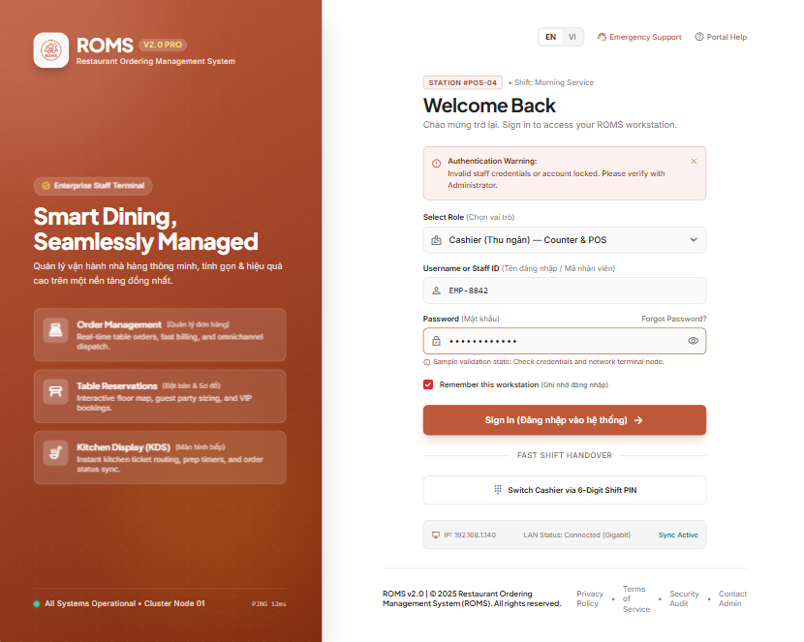

<<Mockup prototype>>
Field Name | Field Type | Description
Username* | Text Box | Mandatory input for staff account username. Validation: Alpha-numeric, 4–30 characters, no whitespace allowed.
Password* | Password Box (Masked) | Mandatory input for staff password. Masked with toggle icon to show/hide plaintext. Min 6 characters.

Database Access
[Provide the design description for the screen/function to access the database here: what table the screen/function would access, which transactions does it make (C-Create, R-Read, U-Update, or D-Delete), and how/purpose of the access (by providing Description and SQL commands)]

Table | CRUD | Description
users | R | Queries employee account record by username to retrieve password hash and account active status.
roles | R | Queries assigned role permissions (Manager, Cashier, Waiter, Kitchen) for dashboard redirection.
audit_logs | C | Records login event timestamp and staff actor ID for system security compliance.

SQL Commands
1/ Query employee account and role details by username:
SELECT u.id, u.username, u.password_hash, u.full_name, u.status, r.name AS role_name
FROM users u
JOIN roles r ON u.role_id = r.id
WHERE u.username = ? AND u.status = 'ACTIVE';
2/ Record staff login audit trail:
INSERT INTO audit_logs (action, target_type, target_id, reason, performed_by, created_at)
VALUES ('STAFF_LOGIN', 'USER', ?, 'Successful authentication', ?, NOW());

2. Table QR & Dining Session Management

2.1 Customer Session Initialization

a. Table QR Welcome & Session Landing (SCR-09)
This screen is the mobile landing page loaded when a customer scans the encrypted physical tabletop QR code using their smartphone. It verifies the HMAC-SHA256 digital token, determines table identity, validates or initializes the active Dining Session, and allows the guest to enter the ordering workflow.
Related use cases:
- UC-08_Scan Table QR Code & Enter Session
- UC-05_Initialize Dining Session

UI Design

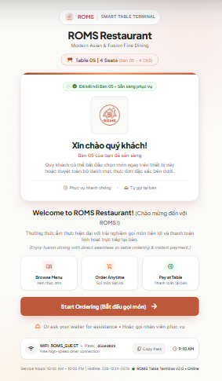
Field Name | Field Type | Description
Restaurant Header & Logo | Header / Image | Displays restaurant branding, welcoming text, and operating hours. Read-only.
Table Identity Card | Badge / Card | Displays verified physical table number (e.g., "Table B04 - 1st Floor Garden") and capacity.
Guest Count Selector | Numeric Stepper / Dropdown | Allows arriving diners to indicate party size (1 to 10 guests). Default value: 2 pax.
"Start Ordering" Button | Button (Primary) | Main call-to-action: Binds device session token, marks table as OCCUPIED, and navigates to Digital Menu (SCR-10).
"Call Waiter" Button | Button (Secondary) | Allows customers who need manual assistance to notify the floor waiter immediately without ordering online.
Invalid QR Alert Banner | Modal Dialog / Alert | Displays error notification if QR code token signature is tampered or expired.

Database Access

Table | CRUD | Description
dining_tables | R, U | Reads table layout and verifies QR token hash. Updates physical status to OCCUPIED upon session start.
dining_sessions | C, R | Checks for active existing session on this table, or creates a new ACTIVE dining session record.

SQL Commands:
1/ Verify tabletop QR token and fetch table status:
SELECT id, table_number, capacity, area_zone, status, qr_token
FROM dining_tables
WHERE id = ? AND qr_token = ?;

2/ Check for existing ACTIVE session or create new dining session:
-- Step A: Check if session already exists for table
SELECT id, start_time, status, guest_count
FROM dining_sessions
WHERE table_id = ? AND status = 'ACTIVE';

-- Step B: If no active session, insert new session and update table status
INSERT INTO dining_sessions (table_id, start_time, status, guest_count)
VALUES (?, NOW(), 'ACTIVE', ?);

UPDATE dining_tables
SET status = 'OCCUPIED'
WHERE id = ?;

3. Digital Menu Operations & Batch Ordering

3.1 Menu Catalog & Order Placement

a. Digital Menu Catalog & Cart Checkout (SCR-10 & SCR-12)

This screen allows seated guests to browse the restaurant's categorized digital food menu, search for specific dishes, view detailed dish modifiers and allergen warnings, stage selected items in an interactive cart drawer, and submit the batch order directly to the kitchen queue.

Related use cases:

UC-09_Browse Digital Menu

UC-10_View Dish Details & Customization

UC-11_Manage Shopping Cart

UC-12_Submit Batch Order

UI Design
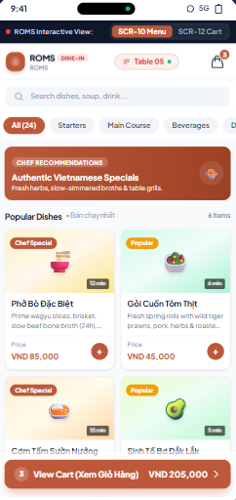

Field Name | Field Type | Description
Table Sticky Bar | Status Bar | Fixed top header displaying table number (e.g. "Table 04") and active session elapsed time.
Search Box | Text Box with icon | Instant search filter by dish name or description. Debounced at 300ms.
Category Tabs | Horizontal Tab Scroll | Filter tabs: All, Starters, Main Course, Hotpot/Grill, Desserts, Beverages.
Dish Item Card | Card Component | Displays dish photo, title, pricing, tags (Spicy/Chef Special), and out-of-stock badge if unavailable.
Add to Cart Button (+) | Button / Stepper | Opens customization popup (portion, spicy level, ice level, note) and appends item to cart.
Floating Cart Trigger | Sticky Badge Button | Shows total item count badge and subtotal price; clicking slides open the Cart Drawer (SCR-12).
Item Quantity Stepper | Stepper (- / +) | Adjusts quantity in the cart drawer. Min = 1, Max = 20. Clicking minus at 1 prompts item removal.
Preparation Note Input | Text Box | Custom cooking requests (e.g., "No cilantro, separate sauce"). Maximum 150 characters.
"Place Order" Button | Button (Primary) | Dispatches batch order with client-side UUID idempotency key to prevent double charging.

Database Access

Table | CRUD | Description
categories | R | Queries list of active categories ordered by display_order for category bar.
food_items | R | Queries active dishes, price, and stock status. Excludes inactive dishes.
dining_sessions | R | Verifies that the target session is strictly in ACTIVE status prior to accepting orders.
orders | C | Inserts a new batch order header record linked to the active dining session.
order_items | C | Inserts ordered dish line-items with initial status CONFIRMED inside an atomic transaction.

SQL Commands:
1/ Query active menu catalog grouped by category:
SELECT f.id, f.name, f.price, f.image_url, f.description, f.is_available, f.is_drink, c.name AS category_name
FROM food_items f
JOIN categories c ON f.category_id = c.id
WHERE f.is_available = TRUE AND c.is_active = TRUE
ORDER BY c.display_order ASC, f.name ASC;

2/ Submit batch order and items in atomic database transaction:
-- Step 1: Create batch order record
INSERT INTO orders (session_id, order_type, idempotency_key, created_at)
VALUES (?, 'CUSTOMER', ?, NOW());

-- Step 2: Insert order item details (Executed in loop for each dish in cart)
INSERT INTO order_items (order_id, food_id, quantity, unit_price, note, status, version)
VALUES (LAST_INSERT_ID(), ?, ?, ?, ?, 'CONFIRMED', 1);

4. Kitchen Order Processing (KDS)

4.1 Kitchen Display System (KDS)

a. KDS Kanban Board (SCR-15)

This screen is designed for kitchen tablet/touchscreen displays mounted at food prep stations. It manages incoming dish tickets in real time through three operational Kanban swimlanes (Queued, In Preparation, and Ready to Serve). Kitchen staff can progress dishes with a single tap or reject items with an audit reason if ingredients become depleted.

Related use cases:

UC-19_View Kitchen Order Queue

UC-20_Start Preparing Dish

UC-21_Mark Dish Ready

UC-22_Reject Ordered Item

UI Design

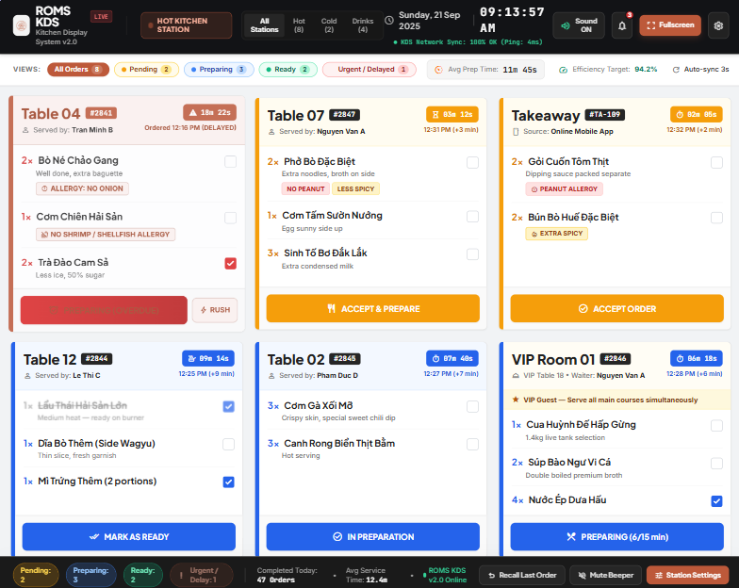

Field Name | Field Type | Description
Lane: Queued | Kanban Column | Lists incoming newly confirmed dishes (CONFIRMED). Sorted FIFO by submission timestamp.
Lane: In Preparation | Kanban Column | Lists dishes currently being cooked (PREPARING) with active elapsed preparation timer.
Lane: Ready to Serve | Kanban Column | Lists finished dishes (READY) awaiting waiter pickup and delivery to guest table.
Dish Ticket Card | Card Component | Displays Table number, dish name, quantity, customer custom note (highlighted), and waiting timer.
"Start Cooking" Button | Button (Blue) | Chef taps to transition ticket state from CONFIRMED to PREPARING.
"Mark Done" Button | Button (Green) | Chef taps when cooking finishes; transitions state from PREPARING to READY and notifies waiter.
"Reject" Button | Button (Red) | Opens modal to select rejection reason (e.g., out of stock) and transitions status to REJECTED.
Urgency Warning Badge | Visual Badge / Alert | Color coded: Green (< 10 min), Yellow (10–15 min), Blinking Red (> 15 min overdue alert).

Database Access

Table | CRUD | Description
order_items | R, U | Reads active kitchen orders (excluding drinks); updates item status through lifecycle transitions.
orders | R | Joins with orders table to retrieve creation timestamps and order sequence.
dining_tables | R | Joins to display physical table number on each kitchen ticket card.
audit_logs | C | Records an audit entry when an item is rejected by kitchen staff with the specific reason.

SQL Commands:
1/ Query active kitchen line items sorted FIFO (Excluding drinks that bypass kitchen):
SELECT oi.id, oi.order_id, dt.table_number, fi.name AS food_name, oi.quantity,
oi.note, oi.status, oi.version, o.created_at
FROM order_items oi
JOIN orders o ON oi.order_id = o.id
JOIN dining_sessions ds ON o.session_id = ds.id
JOIN dining_tables dt ON ds.table_id = dt.id
JOIN food_items fi ON oi.food_id = fi.id
WHERE oi.status IN ('CONFIRMED', 'PREPARING') AND fi.is_drink = FALSE
ORDER BY o.created_at ASC;
2/ Update dish status using Optimistic Locking (Preventing dual chef conflict):
-- Transition from CONFIRMED -> PREPARING
UPDATE order_items
SET status = 'PREPARING', version = version + 1
WHERE id = ? AND version = ? AND status = 'CONFIRMED';

-- Transition from PREPARING -> READY
UPDATE order_items
SET status = 'READY', version = version + 1
WHERE id = ? AND version = ? AND status = 'PREPARING';

5. Table Reservation & Check-in Management

5.1 Reservation Booking & Reception Desk (SCR-17 & SCR-18)

a. Table Reservation & Reception Desk (SCR-18)

This screen is used by restaurant staff and hostesses at the reception desk to manage guest reservations, view upcoming bookings, filter by date and reservation status, assign suitable dining tables, and perform check-in when guests arrive. It also interfaces with the customer-facing reservation portal (SCR-17) to process advance booking submissions and enforce business rules (future booking validation, reservation holding window, and automated no-show release).

Related use cases:

UC-27_Manage Reservation & Check-in

UC-07_Manage Restaurant Tables

UI Design

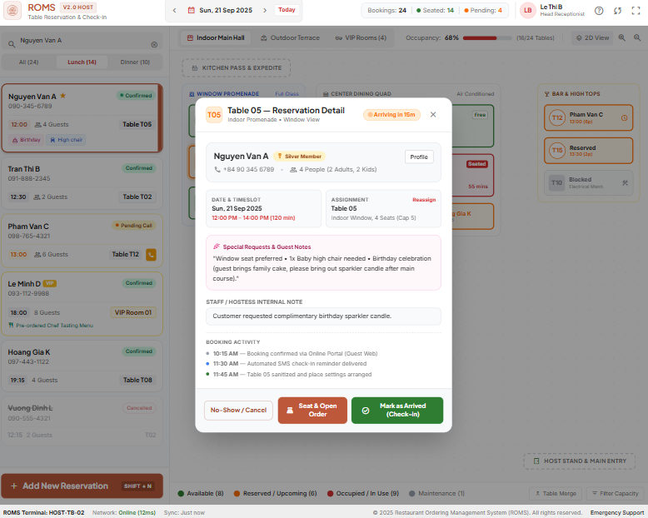

<<Mockup prototype>>
Field Name | Field Type | Description
Booking Date & Time Picker | Date & Time Selector | Selects target dining date and time. Validation: Must be strictly in the future (BR-15).
Party Size Stepper | Numeric Stepper (1-20) | Number of arriving guests. Used to query and allocate dining tables with adequate capacity.
Customer Name* | Text Box | Mandatory customer contact name (2-50 characters). Displays on booking card.
Phone Number* | Text Box | Mandatory phone number (10 digits). Primary search identifier for reception check-in desk.
Dining Notes | Text Box | Optional special dining requests (e.g., high chair, window seat, celebration). Max 200 characters.
Table Allocation Dropdown | Select Dropdown | Lists available restaurant tables with capacity >= party size for selected dining window.
Status Filter Tabs | Tab Bar | Filters reservation list by operational status: ALL, CONFIRMED, CHECKED_IN, EXPIRED, CANCELLED.
"Check-in" Button | Button (Primary Green) | Staff taps upon customer arrival: transitions Reservation to CHECKED_IN, sets table to OCCUPIED, and generates active DiningSession (BR-01).
"Cancel Booking" Button | Button (Secondary Red) | Staff or customer cancels booking. Prompts confirmation dialog and releases reserved table slot.
Search & Lookup Bar | Search Input | Quick real-time filter across reservations by customer name, phone number, or booking reference code.

Database Access
Table | CRUD | Description
reservations | C, R, U | Inserts advance table bookings, queries reservations by date and phone number, and updates status to CHECKED_IN, EXPIRED, or CANCELLED.
dining_tables | R, U | Queries tables by capacity; checks availability; updates status to RESERVED during lock-in window and to OCCUPIED upon check-in.
dining_sessions | C | Creates a new active Dining Session record for the table upon successful customer check-in.
audit_logs | C | Records audit trail entries when a booking is cancelled, modified, or auto-expired by the background scheduler.
SQL Commands:
1/ Query available tables matching party size for target time slot:
SELECT dt.id, dt.table_number, dt.capacity, dt.area_zone, dt.status
FROM dining_tables dt
WHERE dt.capacity >= ? AND dt.status = 'AVAILABLE'
AND dt.id NOT IN (
SELECT r.table_id
FROM reservations r
WHERE r.status = 'CONFIRMED'
AND r.reservation_time BETWEEN DATEADD(minute, -60, ?) AND DATEADD(minute, 60, ?)
)
ORDER BY dt.capacity ASC;

2/ Create new table reservation (SCR-17 Customer / Staff Booking):
INSERT INTO reservations (customer_name, phone_number, party_size, reservation_time, note, table_id, status, created_at)
VALUES (?, ?, ?, ?, ?, ?, 'CONFIRMED', NOW());

3/ Perform Customer Check-in at Reception Desk (Executed in atomic transaction):
-- Step A: Transition reservation status to CHECKED_IN
UPDATE reservations
SET status = 'CHECKED_IN', updated_at = NOW()
WHERE id = ? AND status = 'CONFIRMED';
-- Step B: Automatically initialize new active Dining Session for table (BR-01)
INSERT INTO dining_sessions (table_id, guest_count, start_time, status)
VALUES (?, ?, NOW(), 'ACTIVE');
-- Step C: Update table status to OCCUPIED on Live Table Map
UPDATE dining_tables
SET status = 'OCCUPIED'
WHERE id = ?;

4/ Scheduled Reservation Auto-Release (Background cron job FN-05 executing periodically):
UPDATE reservations
SET status = 'EXPIRED', updated_at = NOW()
WHERE status = 'CONFIRMED'
AND reservation_time < DATEADD(minute, -20, NOW());

IV. Appendix

Assumptions & Dependencies

1.1 Assumptions

ID | Assumption Title | Detailed Description
AS-01 | Single Restaurant Scope | The system is designed, developed, and deployed exclusively for a single, independent restaurant premise. Multi-branch management, central chain administration, franchise hierarchies, and multi-tenant SaaS business models are explicitly outside the current project scope.
AS-02 | Customer Device & Browser Access | Customers possess a personal smartphone equipped with a functioning camera capable of reading standard 2D QR codes and a modern mobile web browser (e.g., Apple Safari, Google Chrome) with network connectivity. Customers are not required to download or install a native mobile app.
AS-03 | Restaurant Hardware Infrastructure | The restaurant facility is equipped with dedicated operating devices: a display tablet or PC monitor for the Kitchen Display System (KDS) in the culinary area, at least one Cashier/POS PC terminal at the counter, and handheld mobile devices or tablets for floor waitstaff.
AS-04 | Cooperative Table Dining Session | Guests seated at the same physical dining table are assumed to belong to the same dining group, share a single active Dining Session, and accept a single consolidated bill upon checkout. Automated individual item split-billing is excluded from the MVP scope.
AS-05 | Menu & Inventory Maintenance | Restaurant management and kitchen personnel are responsible for maintaining and updating menu item availability in real time. The system assumes that active catalog records accurately reflect actual culinary ingredient availability in the kitchen.
AS-06 | Staff Operational Training | Floor waitstaff and kitchen personnel are trained on and strictly adhere to the defined Order State Machine lifecycle (CONFIRMED → PREPARING → READY → SERVED) and update order statuses promptly during operational service.
AS-07 | Continuous Power & Facility Network | The restaurant facility provides continuous, uninterrupted electrical power and adequate local Wi-Fi coverage across all dining tables, cashier stations, and food preparation areas to ensure seamless device connectivity.

1.2 Dependencies

ID | Dependency Title | Detailed Description
DE-01 | Network Connectivity | ROMS depends on a stable network connection for communication between customer devices, staff devices, frontend, backend, and database services.
DE-02 | Electronic Payment Service | Electronic payment functionality depends on the availability of the selected payment service, currently specified as VNPay QR in the project scope. Cash payment remains available as an alternative.
DE-03 | Microsoft SQL Server | ROMS depends on Microsoft SQL Server for persistent storage of users, tables, dining sessions, menu items, orders, bills, payments, and related data.
DE-04 | Backend and Frontend Application Environment | ROMS depends on the planned Java/Spring Boot backend and web frontend environment to provide authentication, role-based access control, business logic, menu, ordering, kitchen, billing, and management functions.
DE-05 | Receipt Printing Device (Optional) | Printed receipts depend on the availability of a compatible receipt printer. The core payment workflow should remain functional even when receipt printing is unavailable.

2. Limitations & Exclusions

2.1 Excluded Features
ID | Excluded Feature | Detailed Description
EX-01 | Multi-Branch and Multi-Restaurant Operations | ROMS supports a single restaurant only. Multi-restaurant, multi-branch, multi-tenant, and franchise operations are outside the current project scope.
EX-02 | Off-Premise Food Delivery | ROMS is designed for in-dining table ordering and does not support home delivery, delivery dispatch, driver management, takeaway logistics, or third-party food delivery platform integration.
EX-03 | Native Mobile Applications | ROMS does not include dedicated native mobile applications for Android or iOS. Customer and staff interactions are provided through web-based interfaces.
EX-04 | Individual Split Billing | ROMS does not support automated split billing between individual diners. Orders within the same Dining Session are aggregated into a single consolidated bill.
EX-05 | Advanced Inventory and Ingredient Management | ROMS does not support advanced inventory management, including detailed ingredient/BOM tracking, raw material consumption, supplier management, or purchase order management. Food availability is managed at the menu-item level.
EX-06 | Customer Loyalty Programs | ROMS does not support loyalty points, membership tiers, reward redemption, or customer loyalty campaigns.
EX-07 | Advanced AI/ML Recommendation | ROMS does not include advanced AI/ML-based food recommendation or personalization. Any food recommendation functionality is limited to the basic/rule-based scope defined for the project.

2.2 Technical & Operational Limitations

ID | Limitation / Constraint | Detailed Description
LI-01 | Network Dependency | ROMS operates as an online web-based system and does not provide offline operation. Loss of network connectivity may interrupt customer ordering, staff operations, and communication with kitchen services until connectivity is restored.
LI-02 | No Online Reservation Deposit | ROMS does not support online deposits or advance payments for reservations. Reservation handling, when implemented, is limited to the table reservation and check-in functionality defined within the project scope.

3. Business Rules

ID | Category | Rule Definition
BR-01 | Constraints | A table can have only one active Dining Session at a time.
BR-02 | Facts | A Dining Session can include multiple Customers.
BR-03 | Constraints | A Customer can participate in only one active Dining Session at a time.
BR-04 | Constraints | An Order must contain at least one valid and available menu item.
BR-05 | Constraints | A Customer can cancel an Order only before it reaches PREPARING.
BR-06 | Constraints | An Order status can only be changed according to the predefined Order State Machine.
BR-07 | Constraints | Only authorized Staff can change the Order status according to their assigned permissions.
BR-08 | Constraints | A Dining Session can be completed only when all associated Orders have reached a final status.
BR-09 | Computations | A Bill belongs to one Dining Session and is calculated from all valid payable Orders within that session.
BR-10 | Constraints | Canceled and rejected Orders must not be included in the Bill.
BR-11 | Constraints | A Customer can access a Dining Session only when the scanned QR code is valid and associated with an active table or Dining Session.
BR-12 | Action Enablers | A recommended item must not be automatically added to the Customer's Cart. Customer confirmation is required before adding the item.
BR-13 | Constraints | A table marked as RESERVED must not be assigned to walk-in customers during the active reservation period.
BR-14 | Constraints | Each Order must strictly belong to exactly one valid Dining Session.
BR-15 | Constraints | A Reservation can only be created for a future date and time. Reservation requests for past timestamps must be rejected by the backend with HTTP 400.
BR-16 | Constraints | A Dining Session can only be transitioned to COMPLETED when no Order Items remain in intermediate states (PENDING, CONFIRMED, PREPARING, or READY) within that session. Checkout is blocked if any item is still being prepared.
BR-17 | Computations | The price recorded on each Order Item is the snapshot unit price at the time the Order was placed (order_items.unit_price), not the current menu price. Subsequent price changes to a MenuItem do not retroactively affect existing Bills.

4. ..

